**ASSIGNMNET 2**

**Task 1: You need to run the html pages in server by using Flask web**

**framework**

from flask import Flask, render_template, request

app = Flask(__name__)

# Login route

@app.route('/login', methods=['GET', 'POST'])

def login():

if request.method == 'POST':

username = request.form['username']

password = request.form['password']

# Perform authentication logic here

# Check username and password against database or any other authentication mechanism

# If authenticated, redirect to chat page

# If not authenticated, show error message or redirect back to login page

return 'Login Successful' # Placeholder response

return render_template('login.html')

if __name__ == '__main__':

app.run(debug=True)

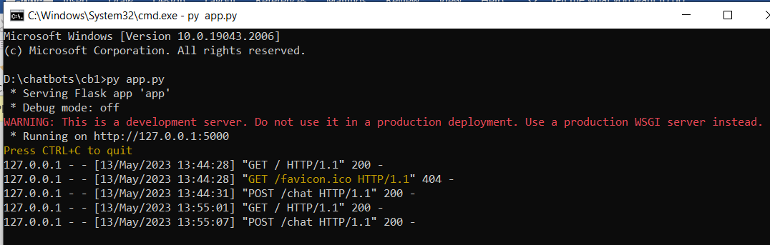

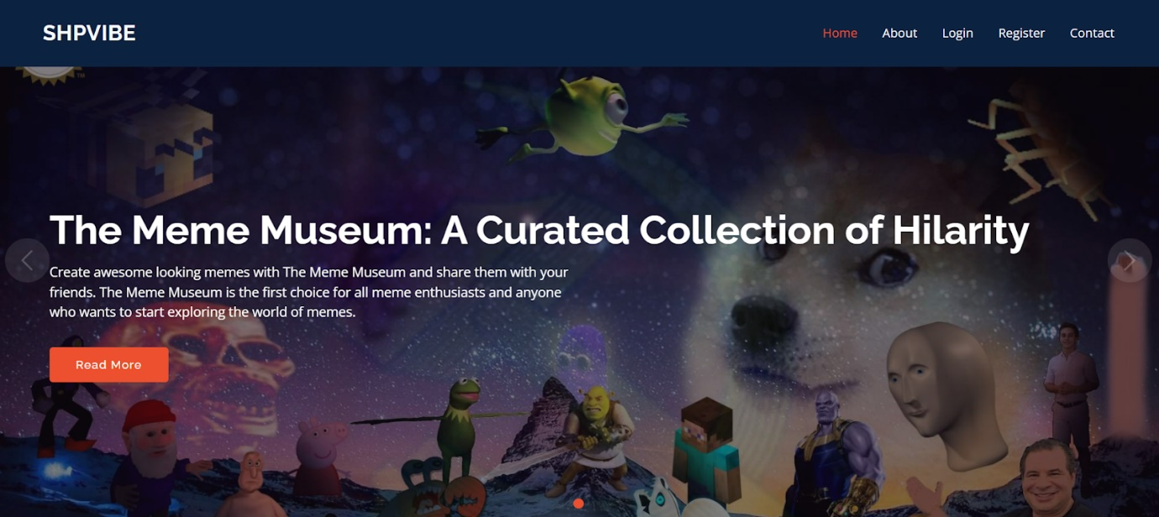

**Task 2: Store the user registration details in IBM DB2**

from flask import Flask, render_template, url_for, request, flash

import ibm_db

app = Flask(__name__)

app.secret_key = "121212"

"""

Create Table 'Users' in IBM Cloud DB2 using following SQL query:

---------------------------------------------------------------------------

CREATE TABLE USERS(

id INTEGER GENERATED ALWAYS AS IDENTITY (START WITH 1 INCREMENT BY 1),

email VARCHAR(30) NOT NULL,

username VARCHAR(20) NOT NULL,

rollno VARCHAR(10) NOT NULL,

password VARCHAR(30) NOT NULL,

PRIMARY KEY(id)

);

"""

def connectDB():

#Enter your IBM DB2 credentials here

conn=ibm_db.connect("DATABASE=;HOSTNAME=;PORT=;SECURITY=SSL;SSLServerCertificate=DigiCertGlobalRootCA.crt;UID=;PWD=;","","")

return conn

@app.route("/")

def root():

return render_template("home.html", title="Home")

@app.route("/signin", methods=('POST', 'GET'))

def signin():

error = None

if request.method == 'POST':

email = request.form['email']

password = request.form['password']

userDB = connectDB()

sql = "SELECT username FROM users WHERE password = '{0}' AND email = '{1}'".format(password, email)

stmt = ibm_db.exec_immediate(userDB, sql)

findUser = ibm_db.fetch_assoc(stmt)

if findUser == False:

error = "Incorrect Username/Password."

while findUser != False:

success = "Hey " + findUser["USERNAME"]

findUser = ibm_db.fetch_assoc(stmt)

if error is None:

return render_template('home.html', title="Home", success=success)

flash(error)

return render_template('signin.html', title='Sign In', error=error)

@app.route("/signup", methods=('POST', 'GET'))

def signup():

if request.method == 'POST':

username = request.form['username']

email = request.form['email']

password = request.form['password']

rollno = request.form['rollno']

userDB = connectDB()

sql = "INSERT INTO users (email, username, rollno, password) VALUES ('{0}', '{1}', '{2}', '{3}');".format(email, username, rollno, password)

ibm_db.exec_immediate(userDB, sql)

return render_template('home.html', title="Home", success="Registration Successful")

return render_template("signup.html", title="Sign Up")

if __name__ == '__main__':

app.run(debug=True)

**Task 3: while user logging in do the login validation (checking the**

**login credentials is correct or not):**

